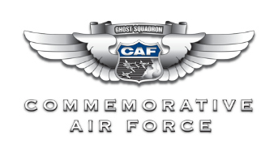
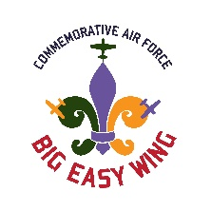
Big Easy Wing Application

Name:
Address:
City: State: Zip:
Phone: Cell:
Email:
Profession:
Aviation Experience:
Military Experience:
Specific Skills:
If Married, Spouse’s Name:
Who Referred you:

* CAF Information |  |  | Annual Dues
Member? | Number: |  | CAF | Big Easy Wing
No | (See Note) |  | Colonel: $200 | Big Easy Wing: $50
Yes: |  |  |  | Active Military: $25
Life: |  |  | Cadet: $40 | Cadet: $10
* NOTE: You must be a member of the CAF to join our Wing. www.commemorativeairforce.org

Join us and pay online at: www.bigeasywing.org

- or -
Make check payable to: | Mail check to:
CAF/Big Easy Wing | The CAF Big Easy Wing  c/o Colonel Harold Buchler, Adjutant  3014 Metairie Rd  Metairie, LA 70001
*The Big Easy Wing is using KAStrack™ to help manage membership. In lieu of this form, please feel free to use https://cafbew.kastrack.com/register/basic-member.

